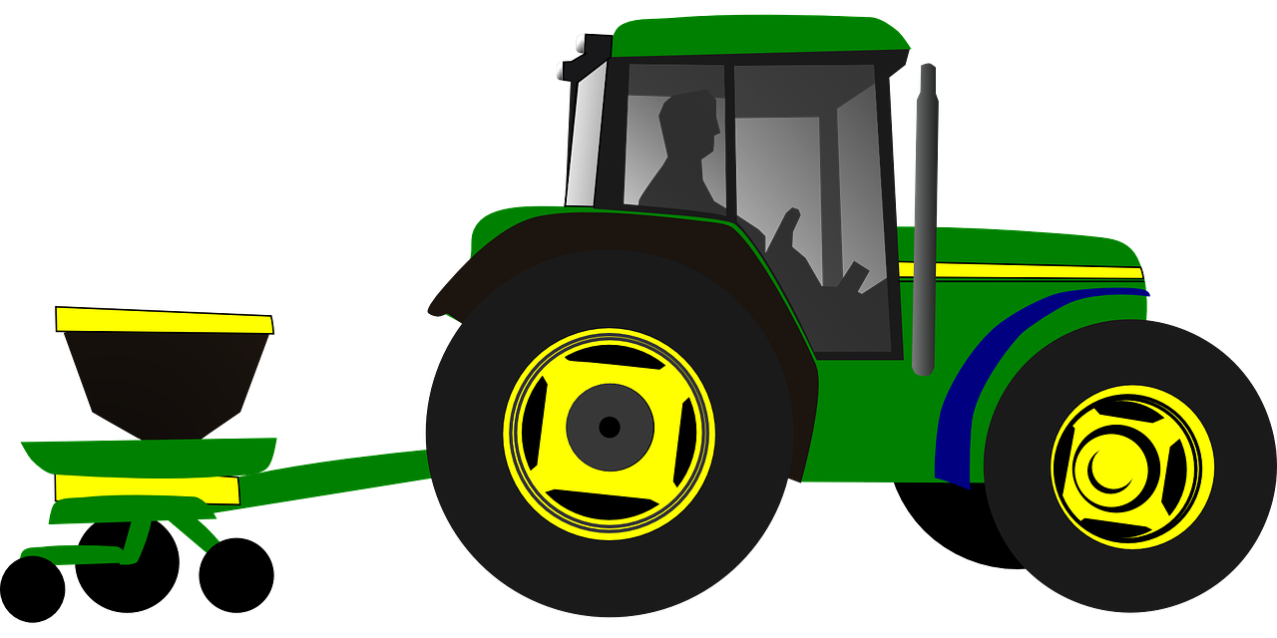

* A planter is a precise seed delivering equipment that drops single seed after a defined length of travel in a row. This is called plant to plant spacing.
* Row to row spacing is maintained by different row unit.
* A seed meter is used to maintain plant to plant spacing.
* Different types of seed meter are there. In our case it is a pneumatic vacuum type.
* The vacuum type seed meter has a rotating discs with orifice mounted on a static vacuum chamber.
* The seed meter rotates and drops seed one by one as vacuum pressure behind the seed is cutoff at the delivery point.
* As we need to maintain a particular forward length travel w.r.t to single seed drop; the seed meter needs to be run w.r.t to forward travel speed of tractor.
* Thus the seed meter can not rotate independently but needs to be coordinated with forward travel.
* In field a constant travel speed is not maintained due to varying slippage of traction wheel of tractor; starting, stopping, slowing down of tractor at different time also causes varying speed.
* To rotate the seed meter w.r.t. actual forward travel of the tractor a ground wheel drive is provided which rolls in contact with the ground and transmits the rpm to seed meter through a chain sprocket arrangement.

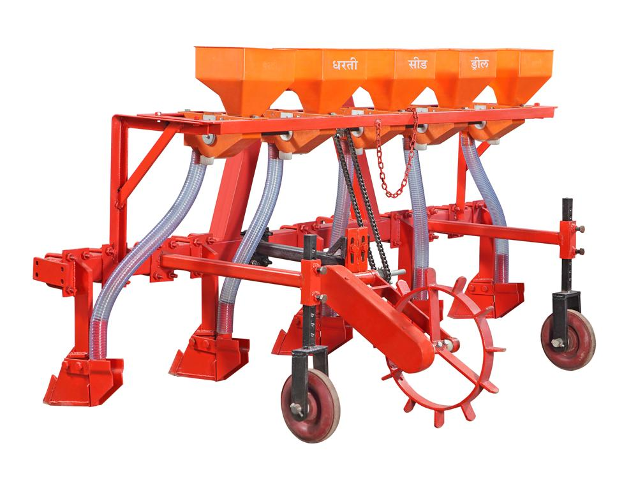Ground wheel

A particular gear ratio between the ground wheel and seed meter is maintained depending on:

* Ground wheel Diameter(D) (one revolution =𝜋D forward distance travel)
* Number of seed picking orifice on a disc(n)= Number of seed dropped in a single rotation of seed meter
* Required plant to plant spacing(S)

**Transmission ratio**

* (driven)Forward travel requirement for one revolution of seed meter= nS
* (driving)Forward travel of ground wheel in one revolution= 𝜋D
* **Ratio= nS/𝜋D**

**Problem with this system**

* Uneven agricultural field: Ground wheel does not touch the soil with required vertically down force at every place.
* Traction required to rotate chain sprocket and seed meter becomes higher than supplied by ground wheel.
* Skidding of ground wheel.

**Electronic driving System**

* An auxiliary ground wheel is provided which does not transmits by mechanical means.
* An encoder attached to ground wheel measures the rpm.
* Another encoder is attached to seed meter to make a feed back loop.
* As per number of orifices in seed meter(22 in our case), plant to plant spacing(0.15 m in our case) and Ground wheel diameter(assume 0.4 m); transmission ratio is calculated.

3.141*0.4=1.2564 m

22*0.15=3.3 m

3.3/1.2564=2.6265

* 2.6255 revolution of ground wheel needs to make one revolution of seed meter.
* The required seed meter rpm(R) is calculated by multiplying a factor(1/2.6265) to encoder measured ground wheel rpm at every instance.
* The current rpm(r) of seed meter is measured by encoder attached to it.
* The difference(error=R-r) between required and current needs to be regulated by the system.
* The error rpm is calculated and regulated by supplying a higher rpm (for +ve error) or lower rpm (for -ve error).
* This rpm is increased/ decreased by increasing/ decreasing voltage supplied.
* Voltage supplied is regulated by regulating pulse width(PWM).
* This PWM is the necessary output from Arduino which needs to be calculated on the basis of both the encoder inputs.
* For immediate regulation of rpm PID technique is employed.

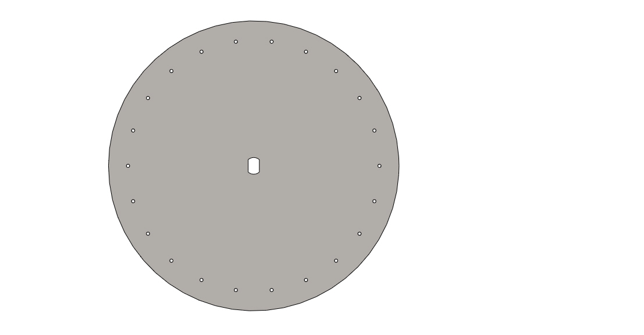

Seed Meter

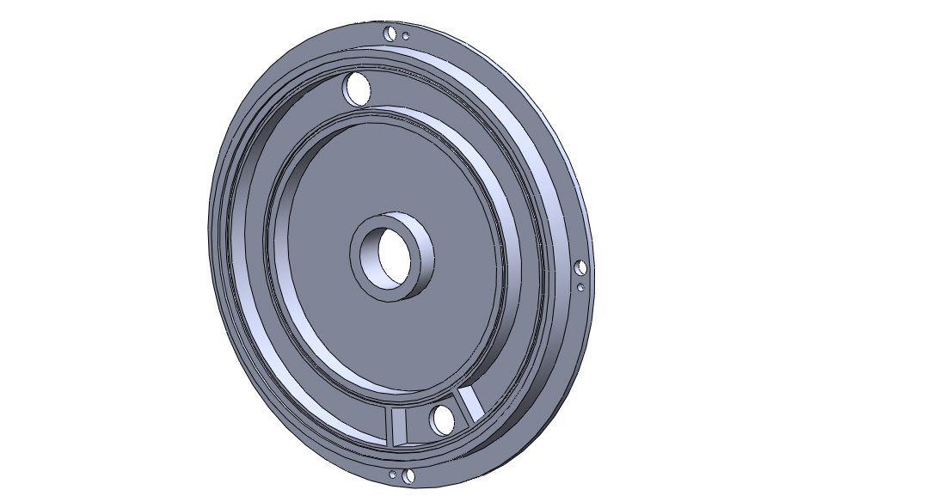

Tilted view of Vacuum Chamber on which Seed meter rotates

The middle hole for rotating shaft,

hole at top for vacuum suction pump,

hole below at pressure cut off to provide atmospheric pressure for seed drop.

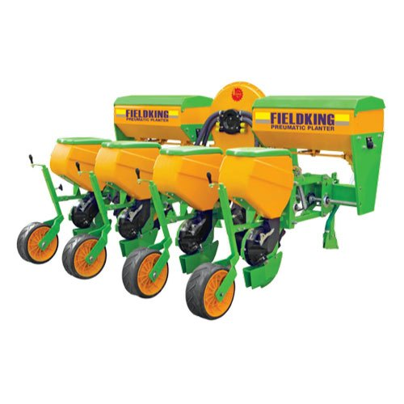

**A Indian pneumatic planter**